**Lab 6- Aarish Salam Memon**

**Attaching Screenshots**

**(i)**

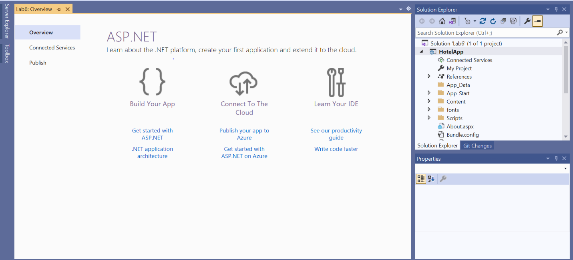

**(ii)**

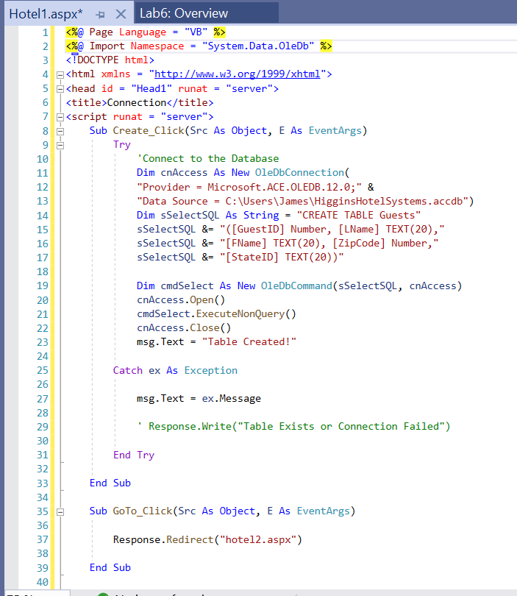

**(iii)**

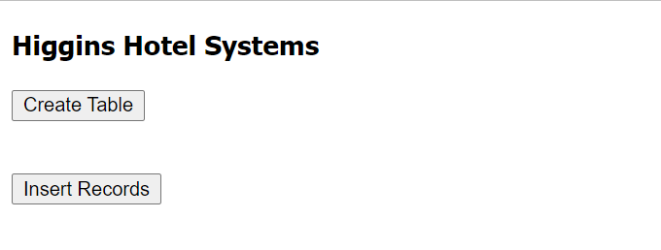

**(iv)**

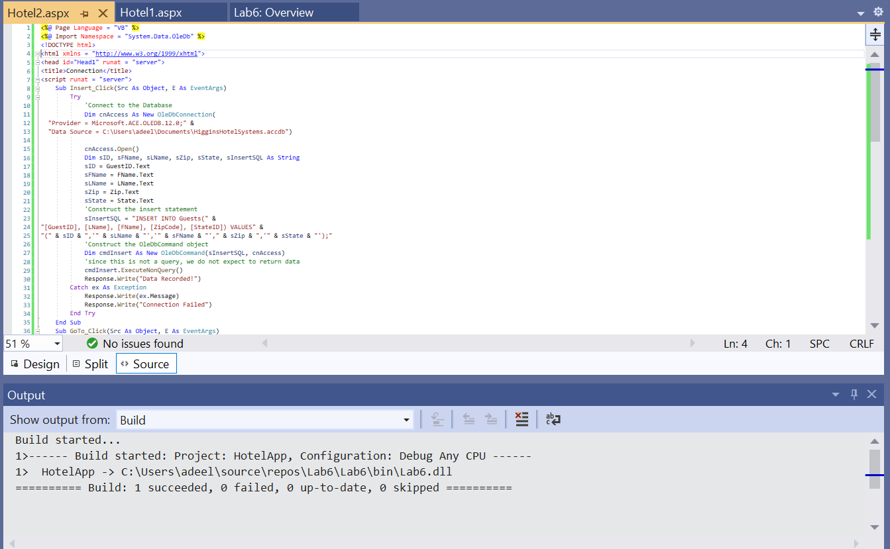

**(v)**

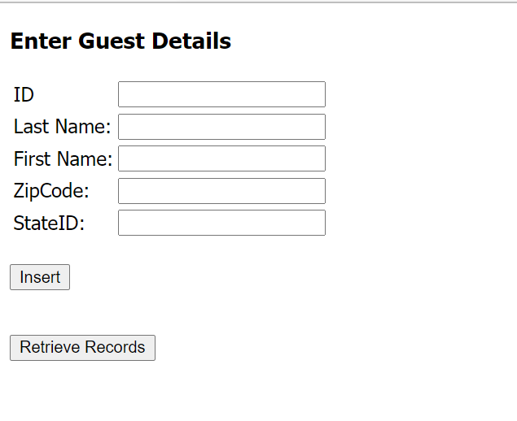

**(vi)**

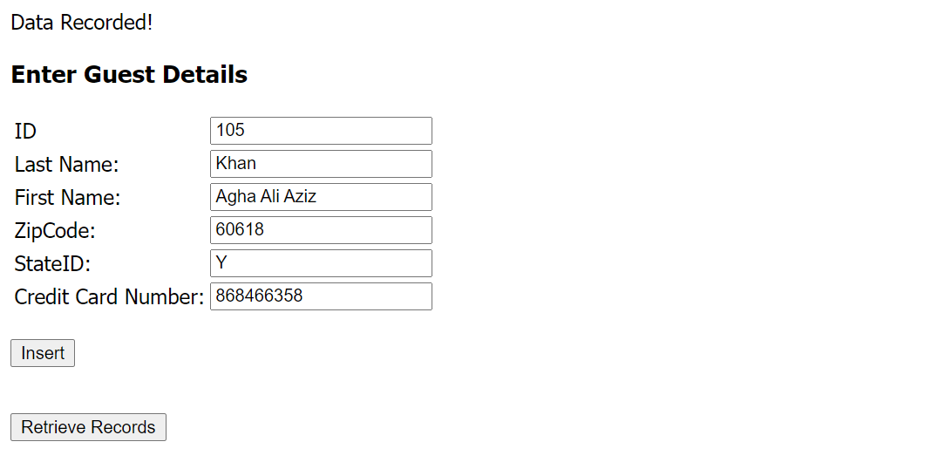

**(vii)**

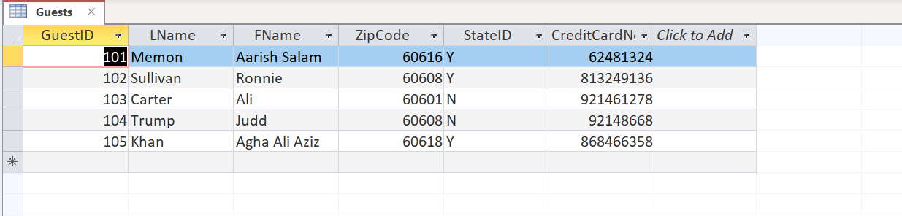

**(viii)**

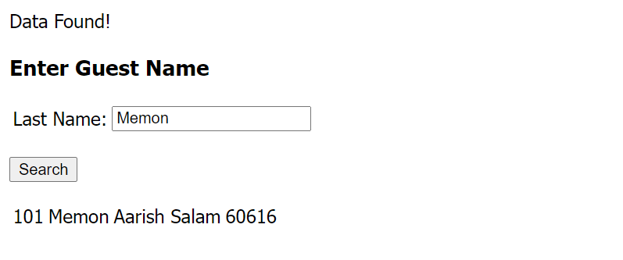

**(ix)**

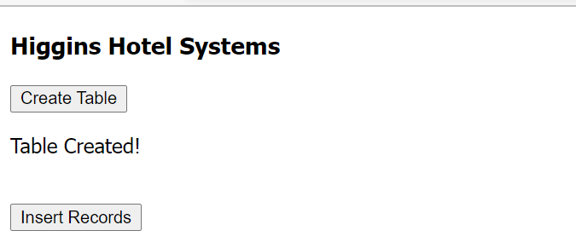

**(x)**

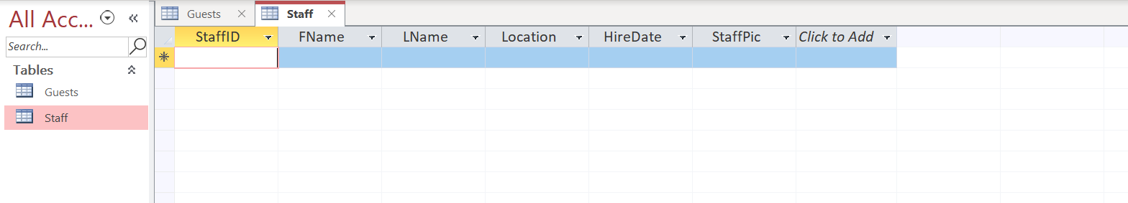

**(xi)**

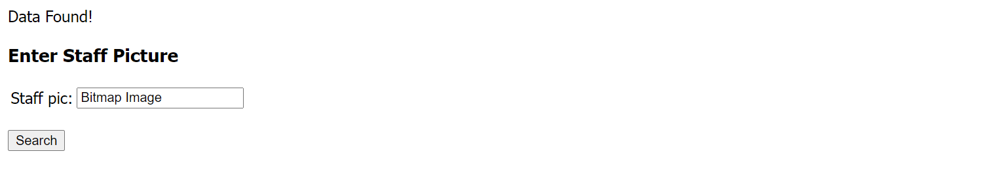

**(xii)**



**QUESTIONS AND ANSWERS**

**Question I. Hotel Reservations, as with other business applications, may be accessed through the cloud. Web services such as AWS and Microsoft Azure may be / are used by companies having reservation systems. Contrast AWS and Microsoft Azure as to the web service architecture they offer their clients.**

**Ans.** That is right most of the reservations systems like hotel reservations systems and similar businesses are shifted to the cloud like Aws and MS Azure , the reason behind that is the reservation systems are used to save the time and effort of the consumer and cloud provides instant speed when it comes to reservation, it keeps itself up to date in micro seconds that helps the reservations systems in a way that if someone cancels their reservation and if the server is on cloud it gets updated right away so a new customer can book the same thing which was not available earlier. Their architecture is so smooth, speedy and secure that it works well for the reservation systems.

**Question II. Data management with reservation systems must be able to accommodate the customer’s requests and requirements. How would you adopt / modify the code for this lab to include a cancellation of a reservation? Place your answer / modified code below this question.**

**Ans.** As in this lab we created reservation system to accommodate the clients and to modify it to delete the reservation is simple as we created the algorithm/logic for the search, same modules can be used for deletion or update as well it would work like if a customer enters their last name it shows the reservation and a button for delete reservation would be added and if someone clicks that button a SQL statement for delete would be executed which would delete the entry from the reservation table.

**Question III. Visit the Web site: <https://www.choicehotels.com/reservations>. Navigate through the Web site and list the various required input to make a reservation at a hotel in a particular location. Take a snapshot of the reservation input text boxes and place it here below your list.**

**Ans.**

First Name, Last Name, Email Address, Country, Phone Number, State, Postal Code, Name on Card, Credit or Debit Card Number, Card Type and Expiration Date is required to book a room through this website, It entails the information for the guest and their payment method to book the room.

**Question IV. Reservation systems may also apply to an educational institute’s registration procedures. Similarities exist between both hotel reservation and educational registration systems. List the similar input items, appropriate files to be created and monitored, hardware to store the data, and network architecture. Place your answer below this question number.**

**Ans.** Yes there are many similarities if we compare the hotel reservation systems and education reservation systems but there is a big difference when it comes to the network architecture because the educational system has many inter-connected departments which are involved in the reservation process because if a student wants an admission in a particular dept, then it would be a series of acceptances and then if everyone accepts then it gets reserved whereas in a hotel reservation system there is no such kind of interconnectivity. Fields would also be many more for the educational reservation platform for example department, subjects, course level and etc. I have to write so much more on this question but I’m running out on time for the submission of this lab.

**Question V. Would you recommend that data for the reservation system be structured or unstructured? Support your answer.**

**Ans.** I would recommend the data to be structured for the reservations systems as that would create a flow in the program and the process of updating would be quick and that is what matters the most in the reservation systems. If the data is structured and someone deletes their reservation it would be a faster response time to make that particular selection available again and that’s the reason, I suggest reservation systems should be structured.